# 1.Introduction:

The prototype must constantly be upgraded in order to keep up with the fundamental trend of acquiring anything advanced. Numerous schools and institutions are currently using computerized course management systems in order to improve the overall quality of education. These systems include the subtraction of students in order to liquefy the course transaction so that it may be readily erased and redone.

In order to provide the computer degree, Woodland University College (WUC) is prepared to convert its course administration system into a computer-based format. They are looking for software that will allow them to manage all of their college, staff, course, student, module, assignment, attendance, schedule diary, and report data.

The Woodland University College's computer science degree program webpage will be described in this report (WUC). As a primary goal, this report is to document every step of the software's development process. Everything regarding the program is covered in this report, from the beginning to the end. Numerous subheadings may be found in this paper.

# 1.1 Project background:

The primary aim of this research is to digitalize the university's current information system. Woodlands University College (WUC) is a modest school of higher education that specializes in providing the highest quality degree programs in a variety of fields.

Dr. Simon White is the course director for the computer degree program, and he is looking for software for computing-related students that can manage all of the college's present requirements in an online environment. Consequently, he may administer the course management system and study the relationship between it and other systems. Main goal of this program is to eliminate the issue that has inherited its roots and causes the job to become dizzy, and with the aid of this software, this will make the task slightly much more straightforward.

# 1.2 Project Aims and Objectives

As the primary goal and purpose of this project, a computerized course management system will make it much easier for students and professors that coordinate relevant data for their specific problems at Woodland University College (WUC).The following are the project's aims and objectives, in particular order:

* To oversee the students and professor's attendance
* To estimate overall movements of students premised on their regular activities.
* To get rid of the bureaucratic system.
* To oversee the split of workers into sections.
* To keep track of the WUC's requirements for the management of staff records.
* Students are given the ability to keep a journal.
* For the instructor to be able to provide assumptions based on the student's work through the submission link.
* To keep the course cohesive, students may locate their course module and the information can be uploaded by the course instructor (if applicable).
* To strengthen the link amongst students as well as the professors by allowing them cope with the problem that they had been confronted with
* Interact with the lecturer as well as participate in discussions with the lecturer.
* To provide such a wide range of academic alternatives for students.

# 1.3 project development methodology

In order to accomplish the assignment accurately and quickly, we used a variety of techniques. Our initial step was to create an official group names and logos. When it comes to implementing creation, that breaks the project down into consecutive stages, each of which contributes equally to the final product.

Installation and testing are required.

Maintenance of Software and the Deployment of Software

User interface (UI) design for a computer system

Design and analysis of the system

Engineering to meet a certain set of specifications

* projects Planning:

The approach through which each individual member's technique, abilities, understanding, and ability must always be amassed in collaboration with the project authorization only within agreed-upon timeframe and budget to attain their continual objective. The WUC generated the information for this article.

* Requisite:

Mostly in duration of such project's lifetime, a collection of processes known as requirements or requisite gathers to assure the qualitative methods, revision, modifications in specifications and documentation.

* Evaluation:

Decomposition of a complicated phrase into its constituent parts in order to extract the necessary data from all this, which should be gathered via an informative interviews only with program leader.

* Layout:

The layout of any commodity serves as a layout specifications for its manufacturing and assembly. The style is depending on the requirements of the customer. As a result, adequate consultation is required prior to the completion of the product.

The WUC-recommended methodology has yielded an excellent execution strategy. Using the prototype that's been made available to the College, an administrative platform has indeed been constructed that really can ensure that their material or system reliability satisfy their premier guarantee.

* Testing

Whenever we were satisfied that the concept was already tested extensively as well as confirmed, our group moved onto next phase of the project.

* Maintenance

The restitution of a previous circumstances modifies its existing system, which might also lead in the addition of new functionality and improvements to it's own existing characteristics. Which will ultimately facilitate the creation of blunder software as well as the preservation of the ceasefire here between server and the user.

# 2. Requirement Engineering:

# 2.1 Elicitation Activities

# 2.1.1 Interview plans

|  |  |
| --- | --- |
| Problem Domain Entities | Elicitation Strategy |
| **Dr.**  **Simons white** **(computing course leader)** | 1. What are the motivations for transitioning from a clerical to a computerized system? |
| 2. What's your foremost expectations as from system? |
| 3. Did you ever use any of the course management software in the past? |
| 4. Would you like the courses translated into foreign accents? |
| 5. Do you also have any choices when it comes to programming languages? |
| 6. Is there a need for any encryption key areas? |
| 7. Would you like the database to recognize user input? |
| 8. Are there any relevant legal regulations that you would like us to include in your system? |
| 9. What is the project's budgeted amount? |

|  |  |
| --- | --- |
| Problem Domain Entities | Elicitation Strategy |
| **Mr. Adams Blake (Course administrator** | 1. How do you really want the course system management to appear? |
| 2. In what platform do you currently use to share data? Would this new system support file sharing? |
| 3. Could you define your responsibility as an administrator in the faculty? |
| 4. What features do you anticipate for such course management system? |
| 5. Would you like your system to have an attendance functionality? |
| 6. Is it difficult to create assessment and class schedules for multiple modules? |
| 7. What records do you maintain on teachers and students? |
| 8. Is there something else you'd want to see in a system? |

|  |  |
| --- | --- |
| Problem Domain Entities | Elicitation Strategy |
| **Dr. Raj Singh (Senior lecturer, Module leader and Personal tutor)** | 1. What are the challenges you encounter in the existing system? |
| 2) Is it essential for students to start sharing recordings to the university? |
| 3) Can it be necessary to assign multiple assignments in a module, or can only one assignment be assigned at a time? |
| 4) How do you feel regarding generating the assignments? Would there be a module leader, or can they be assigned by anyone? |
| 5) Should the website allow for immediate interaction with the family members? |
| 6) What's your recommendations for personal tutor-student methods of communication? |
| 7) What are the primary features you want from the computing course leader and us to upgrade in the new system? |
| Problem Domain Entities | Elicitation Strategy |
| **Mr. Mark Williams (Current computing student)** | 1. What distinguishes Woodlands University College from other colleges? |
| 2) What distinguishes Woodlands University College from other colleges? |
| 3) What different features should be more beneficial for the students? |
| 4) Is there any need of the feedback system for the students to directly interact with module leader? |
| 5) Did you ever used or hear this type of system before and different features? |
| 6) What’s your personal view for sharing all your personal data to the university? |

2.1.2 Interview Findings:

Interview Title: Initial Interview with the computing course leader –Dr. Simon White

Duration:30 min

Interview Date: 2022/6/10

Person in Attendance:

* Pratik paudel
* Alish Bikram Shahi
* Dawa Sherpa
* Aagya Uprety

|  |  |  |
| --- | --- | --- |
| * Interviewer | Question Number | Client Response |
| Alish Bikram Shahi | 01 | What are the motivations for transitioning from a clerical to a computerized system?  Answers:  Its administration must have never had anything easy when it comes for accomplishing the university as directing a activities of all the many departments. As the instructor of a class in which anything is required to be completed on something like a desktop, we may not have the appropriate equipment. Substantial material as well as time-consuming manual processes are making it difficult for us to keep accurate records of our students, instructors, and other personnel. The transition from a handbook to such an automated machine will not only help the faculty and students approach, but also that could preserve hours as well as minimize for level of labor. |
| 02 | What's your foremost expectations as from system?  Answer: As a college administrator, We would like to be responsible for tracking any participant's overall university studies, spanning acceptance through graduation. Keeping such traced back can help both individuals and supervisors optimize its time more effectively. Prospective individuals and their associated information ought to be accessible to somehow be enrolled through into system by the administrator. Student-teacher-staff contact seems to be non-existent. Having an efficient methods of interaction would indeed be beneficial. |
| 03 | Did you ever use any of the course management software in the past?  Answer: No, researchers also don't use some kind if equipment while monitoring lectures as in previously. Mostly throughout past, they might provide significant educational information with recent students using internet, whereas this majority on their curriculum components remained distributed in written version. |
| 04 | Would you like the courses translated into foreign accents?  Answer: For something like moreover present least, let's limit ourselves to just one language, which will be English in the initial release. Mostly in initial edition, then, let's just not bother concerning languages beyond than English. Mostly in upcoming, we will give consideration to this matter. |
| 05 | Do you also have any choices when it comes to programming languages?  Answer: No, designers no one has any intention of imposing any limitations upon this software package that users would like to use. Users remain free to communicate alongside one another in wherever dialect best suits them. Designers would also most certainly want as well as the approach to still be spotless, risk-free, and organized. |
| 06 | Is there a need for any encryption key areas?  Answer: You are free to make use of the same element throughout that function that users play. Users shall typically find as client position, another module leader capacity, the program instructor importance, but also an executive portrayal. Within each of these roles, users must have the ability to designate appropriate environment under something that any user may enter your credentials for active their responsibility. |
| 07 | Would you like the database to recognize user input?  Answer:  Absolutely, researchers intend users are able to feedback information as well as to have it saved in what seems like a system. Specifically during the process of acquiring incoming administrators, component leaders, as well as participants. Every filled-out documentation mostly on details should then be maintained in a safe place. |
| 08 | Are there any relevant legal regulations that you would like us to include in your system?  Answer: They don't even having any considerable measure of awareness well – nearly regulations and indeed the relevant laws, although so insofar that I am aware, these include been some guidelines in which they have obligated to observe. The Copyright Design Act and the Computer Misuse Act are only examples of these types of policies. |
|  | 09 | What is the project's budgeted amount?  Answer: My principal contractor is simply interested in a digitized educational administration. Authorities really haven't throw away sufficient funds anyway at this time. Individuals seem willing and able to pay whatever sum of amount that is requested of them. Everything that we desired was a purely computerized platform with all of its bells and whistles. |

Interview title: Interview with course Administrator Mr. Adam Blake

Duration:

Interview Date: 2022/6/10

Person in Attendance:

* Pratik paudel
* Alish Bikram Shahi
* Dawa Sherpa
* Aagya Uprety

|  |  |  |
| --- | --- | --- |
| Interviewer | Question number: | Client response to Questions: |
| Dawa sherpa | 01. | How do you really want the course system management to appear?  Answer: Now, each component table really will have to be very obvious, which ought to get situated throughout the approximate center located on the document. It need to be simple enough for customers to notice it. |
|  | 02. | In what platform do you currently use to share data? Would this new system support file sharing?  Answer: |
|  | 03. | Could you define your responsibility as an administrator in the faculty?  Answer: As a supervisor in the computer science department, I provide presentations, engage counterparts, and assist instructors. I am in authority of the university. |
|  | 04. | What features do you anticipate for such course management system?  Answer: The location for something like enabling publishing of modular material now have to being provided.  That material that is posted by the program manager as well as component manager should have been accessible to students, and that alone a course manager and module leader should be allowed to publish or update it. There ought to be a grading option that enables module leaders to assign grades to the teachers and students. |
|  | 05. | Would you like your system to have an attendance functionality?  Answer: Undoubtedly, it need to include a function for attendance system. It is expected that now the participant as well as the modules instructor will indeed be ready to submit enrollment information. That operation shall keep a record about that quantity consecutive days that perhaps each learner as well as component leaders completed there attendance, and that would show that knowledge upon that participant's each component leadership's respective individual details. |
|  | 06. | Is it difficult to create assessment and class schedules for multiple modules?  Answer: |
|  | 07. | What records do you maintain on teachers and students?  Answer: |
|  | 08. | Is there something else you'd want to see in a system?  Answer: The response covers even more of this functionality. Furthermore, considering we have newer towards the platform, the UI should really be better and easier in using. |

Interview title: Interview with senior lecturer, module leader and personal tutor -Dr. Raj Singh

Duration:

Interview Date: 2022/6/10

Person in Attendance:

* Pratik paudel
* Alish Bikram Shahi
* Dawa Sherpa
* Aagya Uprety

|  |  |  |
| --- | --- | --- |
| Interviewer | Question number: | Client response to Questions: |
| Pratik paudel | 01. | What are the challenges you encounter in the existing system?  Answer: As a course coordinator, I must maintain control of lecturers and students. Almost all of the paper-based course management is done manually. Actually updating individual item consumes a great deal of effort. Also, I believe such platform is insecure and may cause loss of information. |
|  | 02. | Is it essential for students to start sharing recordings to the university?  Answer: Currently, students do not expected to send recordings towards the university. So that we can plan for future upgrades. |
|  | 03. | Can it be necessary to assign multiple assignments in a module, or can only one assignment be assigned at a time?  Answer: I need imitated every session. Import as well as install of modular material ought to be possible. Professors should really be able to update and delete information, while educators must be able to see anything submitted by tutors. Consequently, this technology might show present, past, and future paths.  We might assign multiple task at a time. |
|  | 04. | How do you feel regarding generating the assignments? Would there be a module leader, or can they be assigned by anyone?  Answer: Instructor should prepare activities with explanations, timescales, as well as dates. It would also be excellent if somehow the service could group called upon assignments creation or submission. This might possibly send out an email with reminders as well as restore information if only one of them try to disclose their assignment. |
|  | 05. | Should the website allow for immediate interaction with the family members?  Answer: Let's leave this out of the initial edition. However, There might be soon to communicate amongst students and program supervisors. |
|  | 06. | What's your recommendations for personal tutor-student methods of communication?  Answer: We have been offering people a plan when they may come to the university and meet professors. In circumstances when students as well as professors cannot directly join, the program might feature a discussion board wherein professors can transmit dates and times with Hangouts links. |
|  | 07. | What are the primary features you want from the computing course leader and us to upgrade in the new system?  Answer: |

Interview title: Interview with current computing student- Mark William

Duration:

Interview Date: 2022/6/10

Person in Attendance:

* Pratik paudel
* Alish Bikram Shahi
* Dawa Sherpa
* Aagya Uprety

|  |  |  |
| --- | --- | --- |
| Interviewer | Question number: | Client response to Questions: |
| Aagya Uprety | 01. | 1. What distinguishes Woodlands University College from other colleges?   Answer: Woodlands University had already initiated a separate standard for education achievement across the board by developing a coursework which is forward-thinking, stringent, but also meticulously planned. This rigorous academic program is balanced out by an extensive athletics schedule and indeed the potential to cultivate creative expression through engaging creative and cultural activities. |
|  | 02. | Did current system work properly? If NOT, what difficulties are you facing in this existing system for all students?  Answer: |
|  | 03. | What different features should be more beneficial for the students?  Answer: The key elements must include evaluations, projects, and course information. Practical examinations, an e-library, plus open courseware may be included. |
|  | 04. | Is there any need of the feedback system for the students to directly interact with module leader?  Answer: Like Online applications as well as modest webpages, I typically implement feedback infrastructure to assist companies progress. A method like this would be a nice complement to our college 's website, in my opinion |
|  | 05. | Did you ever used or hear this type of system before and different features?  Answer: yes, of courses I have used this type of system before |
|  | 06. | What’s your personal view for sharing all your personal data to the university?  Answer: Our enrollment documentation has been sent to it to university. Consequently, there won't have an issue if somehow the program uses its equivalent material over and over again. |

# 2.1.3Other problem domain research **:**

It is the technique for addressing the situation somewhere in an application, in which instance the program will also provide all or most of the material more about issue but restricting its response .In addition to the issue directly, this comprises the willingness to accomplish a solution, as well as the development of a situation in which the alternative may be operated for conjunction with both the situation. The strategic priorities are often used in order to overcome specific difficulty domain for the system.

# 2.1.3.1. Comparable software system

We made an interrogation upon many course management systems and shortlisted a bunch of them, that allowed us through understanding how the program must function, analyzing that system, also benchmarking own framework with such a relevant ones. As per the result of the research we've shared, some of them:

1.EdApp:

EdApp is a learning management system (LMS) for mobile platforms that has been developed only with objective of being simple and use for instructors while also being engaging for learners. Organizations may leverage edapp's easy as well as hugely entertaining functionalities such as gaming, dispersed repetitions, micro learning, and virtual learning to keep educating their personnel.

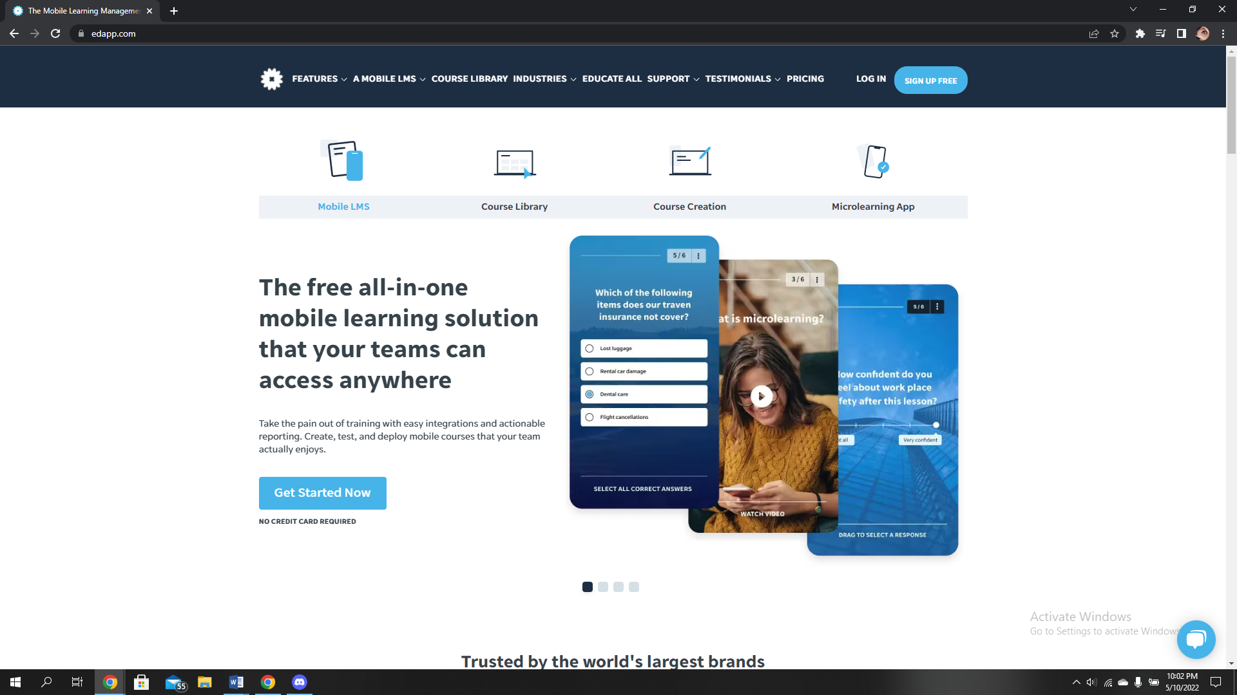

|  |  |
| --- | --- |
| Advantage | Disadvantage |
| 1.Even though they're not able to connect, everyone may contribute to the total learning experience. | not really amicable |
| 2.Fewer quantities of material make it a bit easier to accomplish and recall. |  |

1. Canvas

Canvas is a learning management system, generally described as an LMS, that seems to be accessible on the internet. This tool can be used by educational establishments, instructors, and students that access and analyze online program educational materials, but it is also often used convey regarding developing skills and learner accomplishments.



|  |  |
| --- | --- |
| Advantage | Disadvantage |
| 1. Knowledge transfer and access management are made simpler thanks to the well-defined API of the software package. | 1. There's a few challenges concerning alerts being deferred. |
| 2. Module leaders might evaluate as well as analyze tasks without reinstalling anything through using rapid reviewer facilities. | 2. Navigating is difficult because of the high volume of people. |

# Record Management System

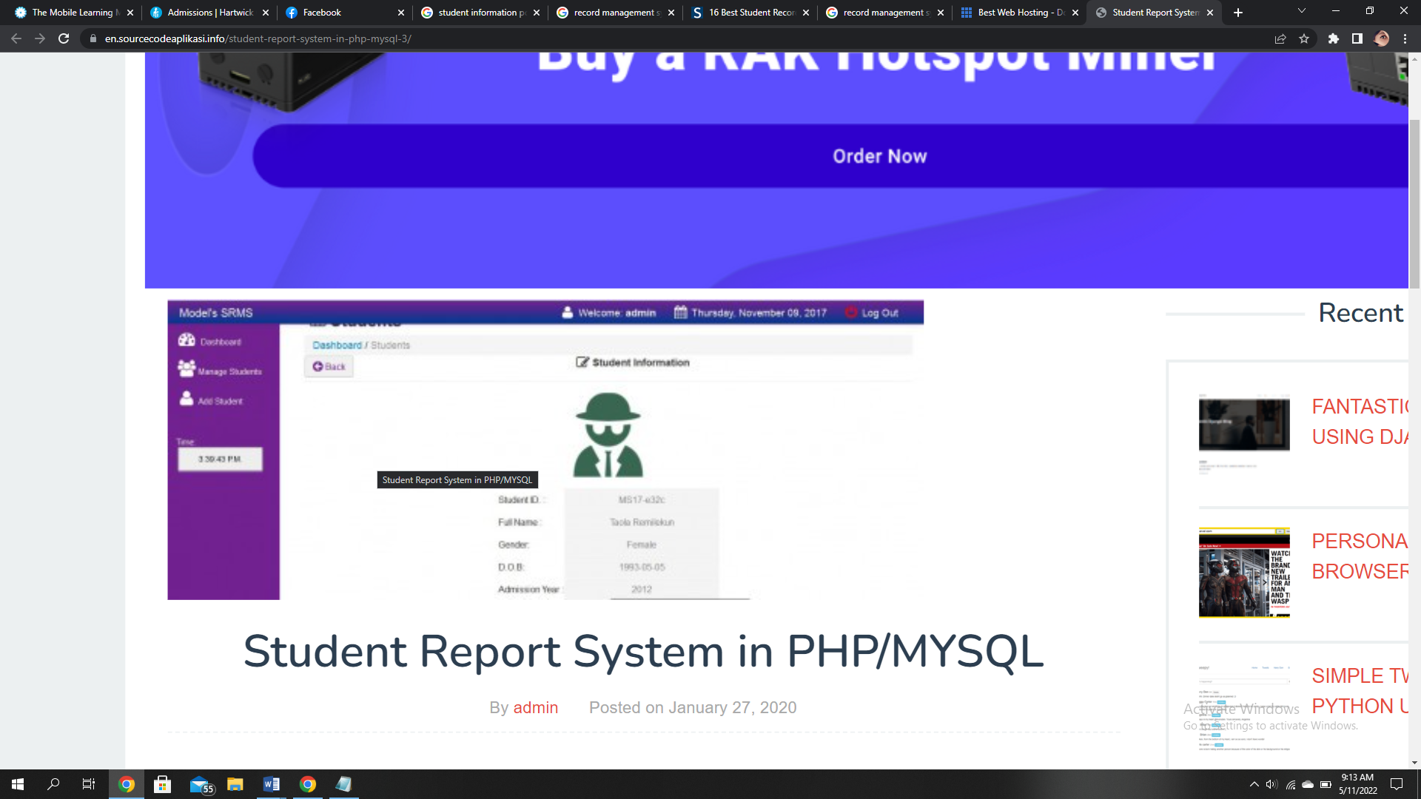

To begin, the aforementioned site provides detailed information about students, but the Nile does not provide any such particular information about users. This will be convenient for the whole user to understand any academic tasks although from the above layout there's really no relevant course activities.

The aforementioned site doesn't have that many capabilities like Nile. In Nile, we can observe current and previous grades as well as the next courses which we are intending to study even though the above features just does not have the sort of functions.

2.1.3.1.2. Student

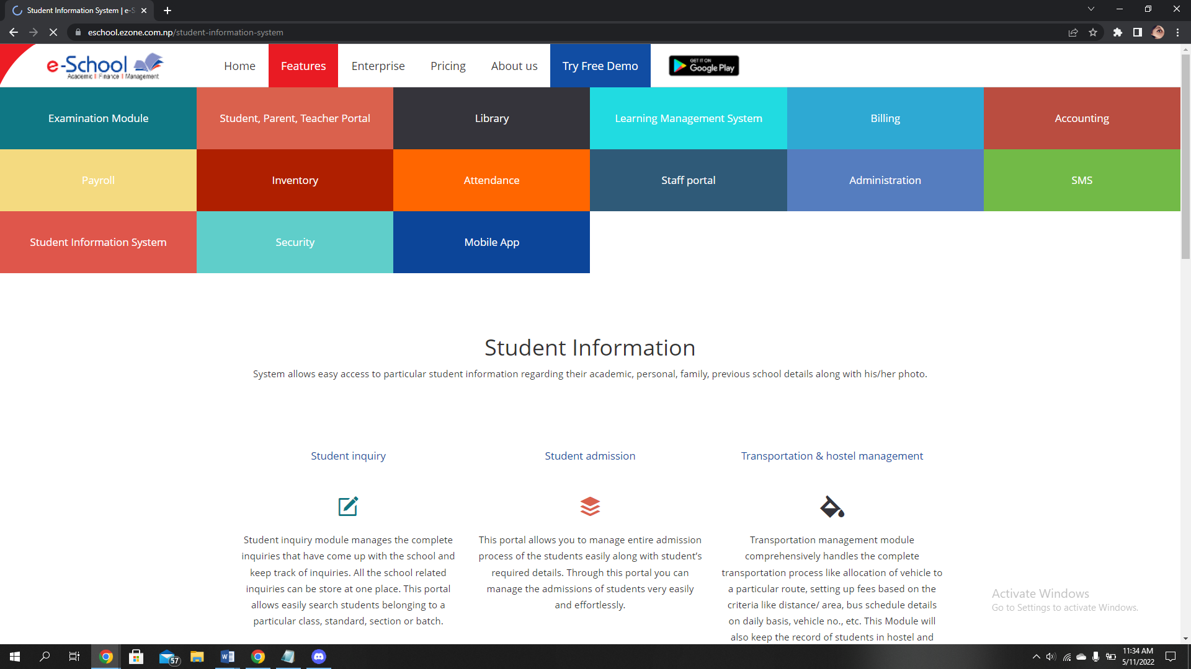

Comparison from the above student site with the nile. The learning management system is one of significant for the student which assists to examine the module courses and other activities. The abovementioned site displays various sort of capabilities like billing, Administration and many other. Comparative with the nile illustrates that there isn't equivalent functionality in nile but in nile we can access the course module like forthcoming modules, ongoing modules etc that would be more simpler for learning.

# Development Relevant legislation :

This encompasses legislation to encrypt the information as per the specifications, reform efforts, tracking progressive policies, legislative the basic component for operating society. Consequently, whenever designing application, the program needs to observe specific standards to accomplish quality assurance with in process. Obviously, it's really the primary objective of regulation seems to be establish the optimum software reliability cause of such it works out cheaper plus reduce workers exposure to hazardous. Most of the other acts are highlighted elsewhere here:

* Communication Act of 1934:

The Communication Act of 1934 created the National Communication systems Commission, an independently U.S. authority regulatory authority for aspects of international telecommunications via broadcast, t.v, fiber, as well as, ultimately, spacecraft. The Communications Act aims to protect people facing pressure on web. During pretty recently technological economy, social networking sites may sometimes be utilized by individuals to express harmful statements.

* The Computer Misuse Act:

The Computer Misuse Act is a federal law which governs as to if individuals are permitted to exploit devices or perform operations mostly on application platform. The legislation inhibits all personally identifiable information to somehow have devoured through big troubles.

This implies for accessing to such a software platform and capture private information as well as to pose a risk to that same equipment only with assist by viral infection something absolutely forbidden.

Unlawfully change for access or damage to computers, that encompasses: malicious as well as unregulated deletion to systems or information

* Data Protection Act:

The Data Protection Act strives to defend everyone that has personally identifiable information maintained on either a computer. It's really fundamental just because it produces necessary guideline for such institution to receive its personally identifiable information, to safeguard its appropriate records topic, to execute its laws. This protection act safeguards the essential sources of evidence from even being misappropriated through maintaining that because an user obtains direct exposure to subscriber information or may amend everything appropriate to most their requirement.

In order to transfer personally identifiable data, an application requiring authorization for doing so it must be submitted either by supervisor of such collection. The data owner outlines which information is protected, why they desire to maintain this and who has accessibility to all of it. Act will be much more defensive as per its characteristics sealing ahead to it would be additional secretive.

# Equality Act:

From the vantage point of information privacy as well as discrimination legislation, the above paper outlines its notion of "Artificial impartiality" towards individuals with impairments. The revised Act retains this provision, but lowers the barrier. Individuals with autism will not be "substantially disadvantaged" throughout the foreseeable especially indicative of the general public. Originally, an item can never be used by a handicapped person if it was "impossible or unreasonable difficult." In light of the many ways in which disability prejudice and security requirements regulations vary from those that apply towards other protected groups, such investigation shows that somehow a strategic objective to Artificial fairness is required.

For individuals with autism, the Current Legislation (2010) helps streamline employment equity constitution besides delivering protection measures for nine "discrimination laws," also including Artificial intelligence - based equality for individuals with autism, demonstrating how merging privacy security but instead individual freedom bill permits exciting challenges for impairment organizations and  electronics organizations.

# 2.1.3.2.2. General Data Protection Regulation(GDPR):

The General Data Protection Regulation (GDPR) seems to be the most comprehensive information as well as data integrity legislation mostly in nation, while then it was enforced since May 2018. Corporations everywhere then innovation pursue nor accumulate information about individuals with in European Union (EU) are subject to government regulation, despite the reality that they have been formulated but instead approved mostly by European Union. And according to regulatory frameworks, personally identifiable conventional data processing of individual persons who have been located in the European Economic Area (EEA) must be processed in accordance with certain terms and conditions but instead specifications. This same legislation needs to apply toward the certain endeavor of it's own spot rather than which of the data subjects' residency status or accommodation has always been encoding personally identifiable information who've been domiciled inside this EEA.

Designers produced these webpage for function as little more than a reference in small and medium enterprise proprietors who would be grappling through special issues. Although its generally aimed being a substitution or expert assistance, this might help elucidate whether companies will emphasis its Existing regulatory initiatives. Subsequently, the European Data Protection Law, that provided essential database privacy and anonymity regulations and from which national sovereign country founded its very specific corresponding legislation, was adopted in 1995 by the EU.

The most important aspects of the GDPR's regulatory framework are:

* Data Security:

Countermeasures can also include something from compelling corporate colleagues to involved in the proposed authorization all domains in which identifiable information is given through dealing using service providers who just use point encrypted communications as element on standard security procedures.

* Data protection officers:

The recruitment of either a relevant authority seems specified per Article 37. A privacy shielding executive (DPO) has always been compelled whereas if manufacturing has always been decided to carry around by a competent official excluding the perhaps tribunal of law or autonomous legal security agencies starting to intervene throughout with there legislative capabilities, whereas negation secondary processes incorporate detailed and timely oversight of information assets on such a wide dimension, but instead whether a secondary processes implicate special subgroups of information collected as well as personally identifiable accused of convicted felon prosecutions as well as misdemeanors  or sometimes when the secondary processes necessitate systematical oversight of information assets on such a sizeable spectrum . There are indeed a numerous advantages to keeping everyone occupying such capacity. Through summary, individuals are responsible for ensuring that the General data protection regulation was indeed adopted and implemented only within agency, recommending employees concerning his\her information privacy accountabilities, under going information privacy workshops, quality assessment but rather supervising Compliance with relevant, as well as striking a balance with policy makers.

2.1.3.2.3. Educational Relevant Legislation:

# 2.1.4.3.3 Academic literature review:

This research study seems to be a document that summarizes which thus illustrates level of expertise of something like relevant research material about any predefined matter besides arranging it all in contextual.

# 2.1.3.3.1 Example project relevant research

# 2.1.3.3.2 Development Relevant Implications of Research: